**SYNOPSIS**

**Report on**

**EMPLOYEE MANAGEMENT SYSTEM**

**by**

MANSI PANWAR

ROLL NO: 2200290140087

**Session:2023-2024 (III Semester)**

Under the supervision of

**Prof. Dr. AMIT KUMAR (Assistant Professor )**

### KIET Group of Institutions, Delhi-NCR, Ghaziabad

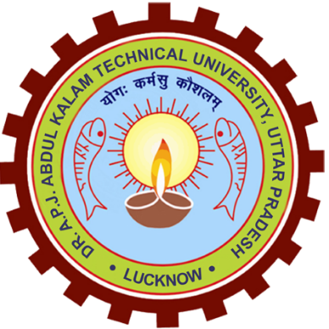

### Department Of Computer Applications

**KIET GROUP OF INSTITUTIONS, DELHI-NCR, GHAZIABAD-201206**

(2023-24)

**TABLE OF CONTENTS**

Page Number

1. Abstract 3
2. Introduction 4
3. Project Objective 5-7
4. Literature Review 8-9
5. Data Flow Diagram 10
6. References 11

**ABSTRACT**

Companies and organizations, large and small, usually have a huge army of people working under them. In such a scenario with a large number of personnel to manage, it becomes difficult to efficiently monitor and manage the activities of human resources. Such companies and organizations need sophisticated employee management systems that can handle everything related to their human resources.The purpose of this project isto set up an advanced employee management system that integrates all relevant information from the enterprise's human resources department. It has the main components of managers and employees. The manager is responsible for companyinformation, vacation management, and payroll, and also adds adjustments to employee details. Similarly, employees can use this system to check vacation status, view salary details and annual leave lists, and file or cancel complaints.

**INTRODUCTION**

An employee is a very important part of any organizations. Without the employees, there would not be any proper functioning of the organization. Employees are the backbone of any company. The employee management system is an application that will track the records of all the employees of the organization. This application will contain the details like name, designation, salary information, attendance details, leave details, client details, project details etc. The performance of the employees can also be kept track of through this application. This application can contain the administrator who can post the announcements, holidays, birthdays and notes. This will be one of the interesting projects that one can work on and implement in a real-time world.

**LANG**

**PROJECT OBJECTIVE**

Employee management systems are software tools that help organizations manage and streamline their HR processes, such as employee data management, payroll processing, benefits administration, and performance tracking. Here are some benefits of using employee management systems:

1. **Increased efficiency:**  
   The benefits of Employee management systems automate many HR processes, which can save time and reduce errors. For example, employee data can be stored in a centralized database, making it easy to access and update. This can eliminate the need for manual data entry and reduce the risk of errors.
2. **Improved communication:**  
   The benefits of Employee management systems can facilitate communication between HR departments and employees. For example, employees can use the system to access information about their benefits, request time off, or communicate with HR representatives. This can improve transparency and reduce misunderstandings.
3. **Better compliance:**  
   One of the best advantages of Employee management systems can help organizations comply with legal requirements related to HR. For example, the system can automatically calculate payroll taxes and ensure that employees are classified correctly. This can reduce the risk of legal penalties and fines.
4. **Enhanced employee engagement:**Employee management systems can provide employees with tools to track their performance and career development. For example, the system can provide employees with performance feedback, training opportunities, and career advancement resources. This can increase employee engagement and reduce turnover.
5. **Data-driven decision-making:**  
   Employee management systems can provide organizations with data and insights into their HR processes. For example, the system can provide data on employee turnover rates, absenteeism, and productivity. This can help organizations make data-driven decisions to improve their HR processes and overall performance.
6. **Optimizes Internal Processes:**  
   It is challenging and time-consuming to manage different HR processes, but an employment management system can assist in optimizing internal operations. It can help you hire, track employees’ performance, manage payroll, and more. With workforce management software, you’ll be able to Keep track of all your employees, including their benefits and salary information. Along with it can help in Receiving automatic reminders when it’s time to pay your employees and measuring employee performance.
7. **Improve the Work Environment:**A good staff management system can help you [improve the work environment](https://desktrack.timentask.com/blog/healthy-environment-for-perfect-work-life-balance/). Employees who are happy are more likely to perform well and be productive. This means that your employees will have a better chance of staying with your company, which is important if you want to grow.
8. **Cost Effective:**EMS is a great example of how businesses can use technology to lower costs and increase productivity. This Staff Management System helps your business streamline processes, increase efficiency, and improve productivity by automating routine tasks such as hiring, firing, tracking timekeeping, and payroll. This can help you save money in the long run because you’ll no longer have to pay employees for administrative work that isn’t core to their job description.
9. **Ensures Employee Motivation:**Motivating employees is one of the best ways to increase productivity and outcomes. With the use of an effective Employee management solution, you can give employees the right incentives, communicate with them on a regular basis, and motivate them to work harder. It helps you to motivate your employees in many ways. You can use it to provide promotions and rewards for outstanding performance, track the performance of individual employees and make sure that they are doing their job well, etc.
10. **Saves the HR Team Time:**Business management software can help to save you time and resources. The HR department is often responsible for a huge amount of administrative tasks, including:
    * + Processing employees’ paperwork and benefits
      + Processing employee payroll
      + Time and attendance management for employees
      + Developing and managing employee training programs
      + Managing employee leave requests, transfers, terminations, and other employment matters

The above tasks can be time-consuming and difficult to do manually. Using an automated employment management system, you will be able to automate many of these processes. By doing this, your HR team will be able to focus on more strategic tasks, saving them valuable time.

**LITERATURE REVIEW**

1. **Existing System**

The existing employee management system in the organization still uses the ordinary classical methods which are merely based on pen-paper to record the data of their employees[1.][2.]. Large quantities of registers are to be maintained for this purpose which results in downright waste of time in generating reports or searching for employee’s records and loss of data if any file is lost. It is also an arduous task for organizations as it is an expensive process. However, somewhere new technologies such as web based systems, Iot based systems are used but they also are costly and difficult to implement at some places. The other techniques that are in the market are dependent on facial recognition, biometric scan or card punching. But all of these require an external device to be installed in the working area, which is again a costly process and requires regular maintenance[7]. This project eliminates or reduces as much as possible the difficulties of the existing system and avoids errors while entering data. In comparison to the existing system it is cheaper, easy to implement, easy to use, no maintenance required, on time data and saves lots of time .

1. **Proposed System**

The proposed system is based on an application that runs on smartphones, and requires internet connectivity. This system provides facilities listed below:

1. employer has to add employee and required details,

2. employer can set public holiday of an organisation a day before

3. employer can not edit the holidays that have passed

4. employer have to click get salary to get salary of every employee, he will get a salary of previous month

5. employer can edit and delete the employee

6. the employee has to install the app and follow the described procedure to set up the app, and then he has to scan the QR code for In at a time of entering the premises. And, has to scan another QR for Out at a time of leaving the premises,

7. It provide secure and strict rule for attendance marking as employee can only mark his attendance once in a day The only requirement to use this system is that one needs to have a smartphone which is not a big task in today's world. One more thing which is kept in mind for those who don't have smartphone that is every employee needs not have a smartphone. There is an option in the employer app through which employers can mark the attendance of his/her employees

**DATA FLOW DIAGRAM (DFD)**

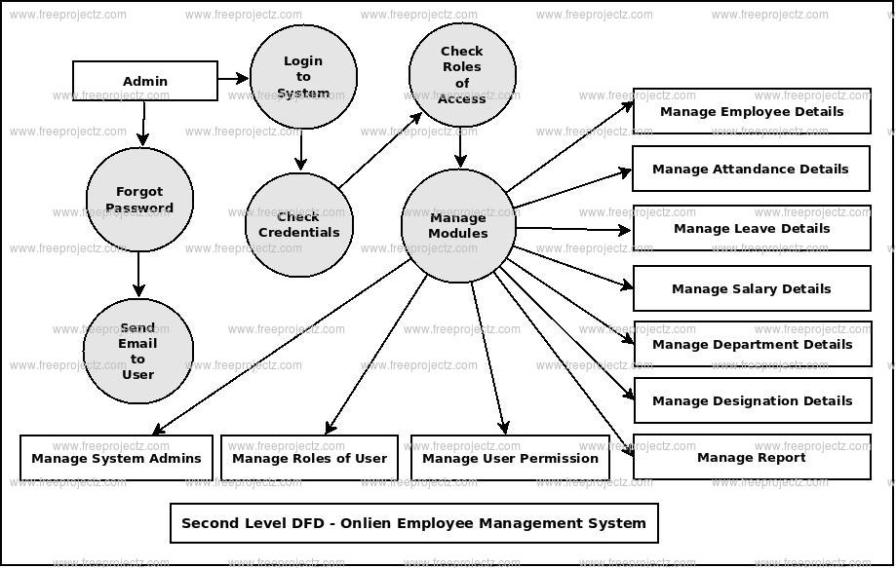

**REFERENCES**

<https://github.com/topics/inventory-management-system>

<https://lnu.diva-portal.org/smash/get/diva2:204828/FULLTEXT01.pdf>